Computer Language Coding Concepts

Related Objects in a Diagram
The principle of related objects is explained in the article Related Objects. This article demonstrates their expression in a diagram.

Related objects are sub-objects or object references inside another object. Related objects are another name for sub-objects and sub-object-references.

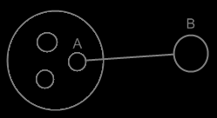

All the circles inside the bigger object are the bigger object’s related objects.

See also: Related Objects, Sub-objects in a Diagram, Object reference in a Diagram

Author & Copyright: Jan-Joost van Zon Date: May 23, 2008 – May 23, 2008 Location: Oosterhout, The Netherlands Status: Finished

